**ICS 414 Check-In 4**

**Team Bobal:**

-Samuel Kim

-Christopher Rodrigues

-John Rasay

For this check-in we focus on improving the UI of the drawings and also create a file menu with a save function and a printing function.

In the last version of our sundial program, the gnomon and dial was drawn and presented using 2 separate window frames. In the latest version there is now only one frame. The frame uses tabs to display the gnomon and dial. The frame also has a file menu, which has a save function that allows you save the two drawings as png images, and it also has print function that lets you print the drawing when you want to, instead of automatically prompting to print once the drawing was created.

DrawingFrame class has 148 lines of code.

SundialPrinter class has 53 lines of code.

In our previous version of the project, we had a total of 943 lines of code. After adding the new DrawingFrame and SundialPrinter class, we have a total of 1096 lines of code.

Each person in our group did research on how to create file menus, tabs and saving images. As a team, we spent a total of 19 hours working on this implementation. Majority of the time spent was based on researching and learning how to implement a class that would enable the gnomon and dial to be presented on one frame using tabs to switch between the two, and also how to create a file menu, with a save and print function. We each spent about 3-4 hours researching and about 3 hours each writing the code.

To test our program, we each tried to save and print the sundials on our own computers. Along with making sure the tabs worked as we intended. From our testing, we determined that when we try to print the sundial, it doesn’t really scale too well.

For future check-ins we are going to try and improve the DrawingFrame class because when we print it doesn’t really scale well. So we need to work on our program being able to resize the sundial to an 8.5 by 11 paper. We will try to make the UI of the dial and gnomon more responsive, meaning that when the user resizes the window the picture should be able to resize based on the size of the window frame. To verify the correctness of our program, we will also try to begin testing the sundial by trying it outside and see if the drawing, scaling and printing is correct.

**SCREENSHOTS**

**LAST VERSION:**

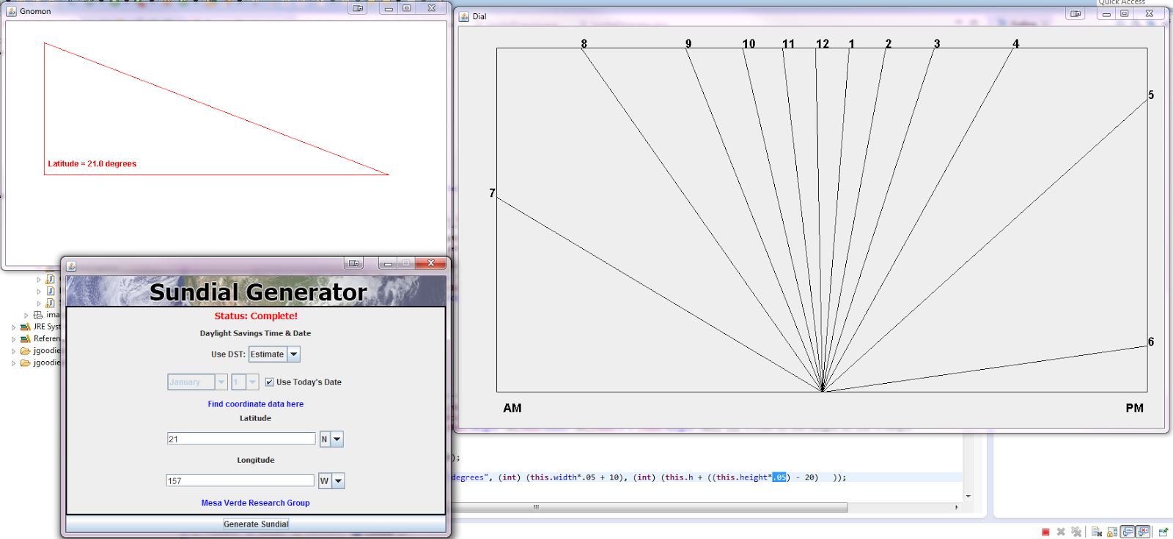

**NEW VERSION:**

New version now has one window with tabs for the two drawings.

The Gnomon

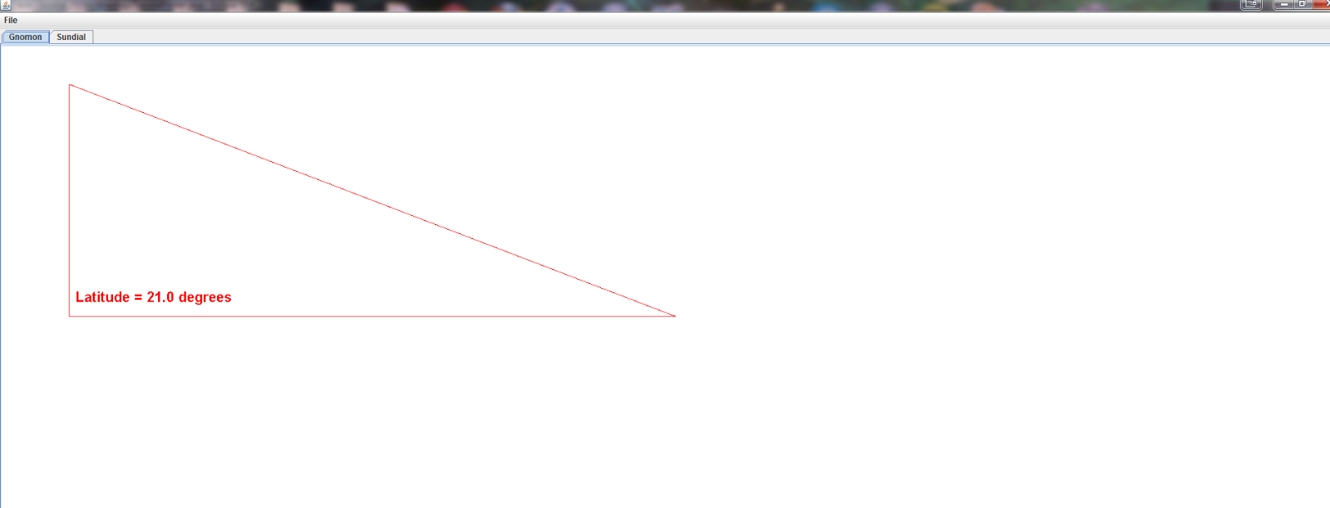

The Dial

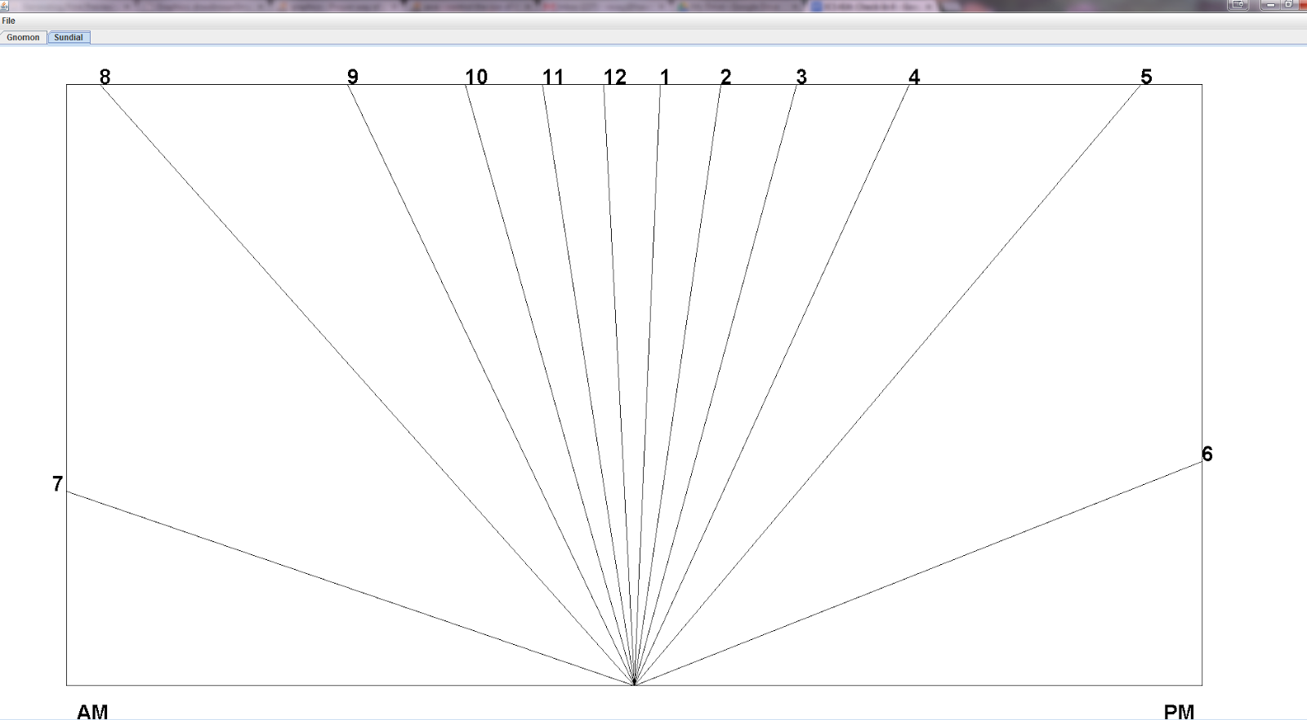

A File menu has also been added, with a print and save function.

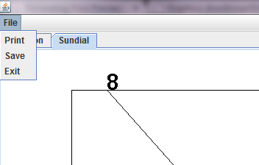

When save button is clicked, both the gnomon and dial drawing is save as png

and the default location is in the same location as the source code.

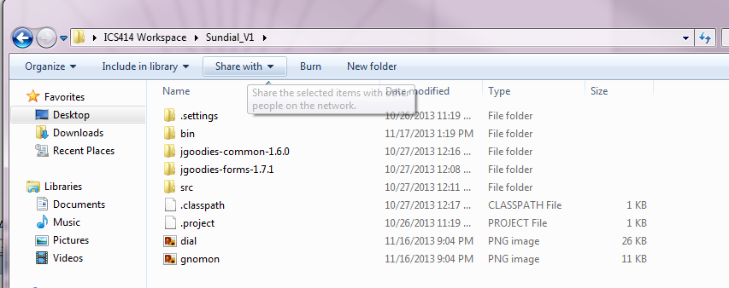

Printing:

Automatically set to landscape orientation

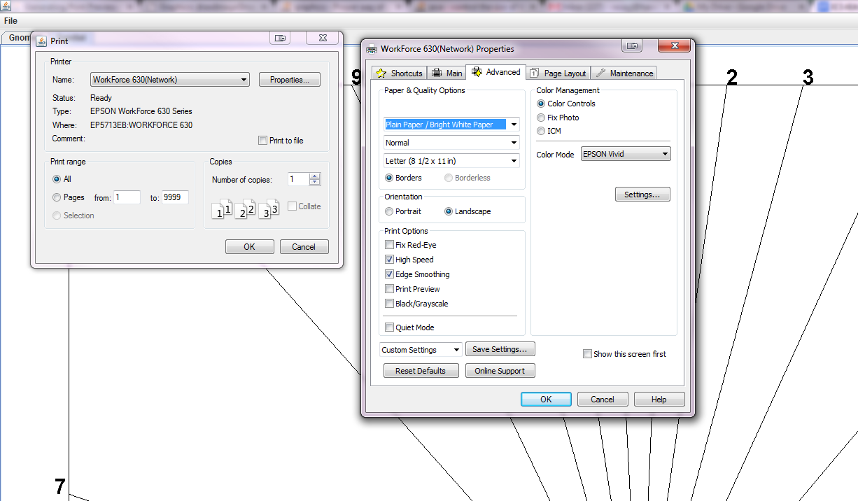

Print Preview:

